Portfolio Project

September 2019

By Charles Thomas Merrick-Bisset

# Contents

Contents 1

Introduction 3

Team Roles 3

Game Design 3

Game Concept 4

Backstory 5

Feature Goals 5

Top Priority 5

Mid Priority 5

Low Priority 6

Controls 6

Software Used 6

Scrapped Ideas 6

2D RPG 6

Requirements Specification 7

Functional Requirements 7

Non-Functional Requirements 7

Assets Required 7

Player Interface 8

Arena 8

Player 8

Enemies 8

Undead - Melee 8

Turrets - Shooter 9

Boss - ??? 9

Weapons 9

Sword 9

Bow 9

Business Model/Games Development Life Cycle 10

Usability testing 10

Functionality testing 10

Testing Methods 10

Sound Design 11

Inspiration 11

Mechanics 11

Story/Backstory 12

Enemy Design 12

Aesthetic 12

Concept Art - Enemies 13

 13

Concept Art - Player HUD 14

Final Design 15

Enemy 15

Turret 15

Player 16

UML Diagrams 16

Test Log 17

Difficulties 18

Sources/Credit 19

Technical Design 19

Mechanics and Gameplay 19

Showing my work online 20

# Introduction

I’m Charles Thomas Merrick Bisset this is the documentation for my portfolio project the development team are as followed Charles Thomas Merrick Bisset. I’m the only team member I chose to work alone so I take responsibility for everything and every role. The First half of this portfolio is for the 29th November 2019 and will be assessed by Gavin Baxter. I will be making this game in unity either from home or in the university labs. I know working yourself usually makes things more risky but I kind of wanted to work on a kind of dream project so I think its less risky because I have more passion for it.

## Team Roles

Charles Thomas Merrick Bisset Everything.

B00314125

# Game Design

## Game Concept

The main concept for Rise Again is it’s a 2d platformer were which level you move onto is determined by which path you want to chose Dark or light. The theme of the game as a whole is medieval fantasy style with very gothic tones think of it like the old school castlevania games. As a person I really want to make a 2d rpg but I don’t have enough time for this course so I decided the second-best thing to do would be to make a 2d platformer. I based this decision on the game megaman x as I like the free going movement and feeling of difficulty through out the level but on the opposite end I like the look and the concept of castlevania but I hate the gameplay. So I thought why not try the best of both worlds.The games main audience is I would say for a casual audience just for people who want an interesting story and ok gameplay.

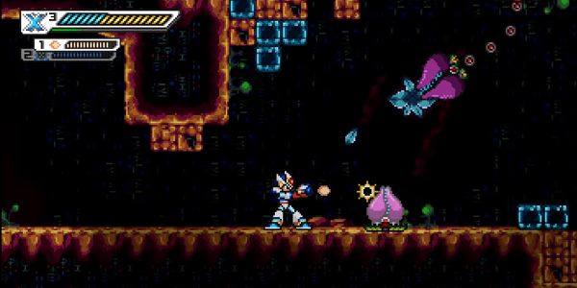

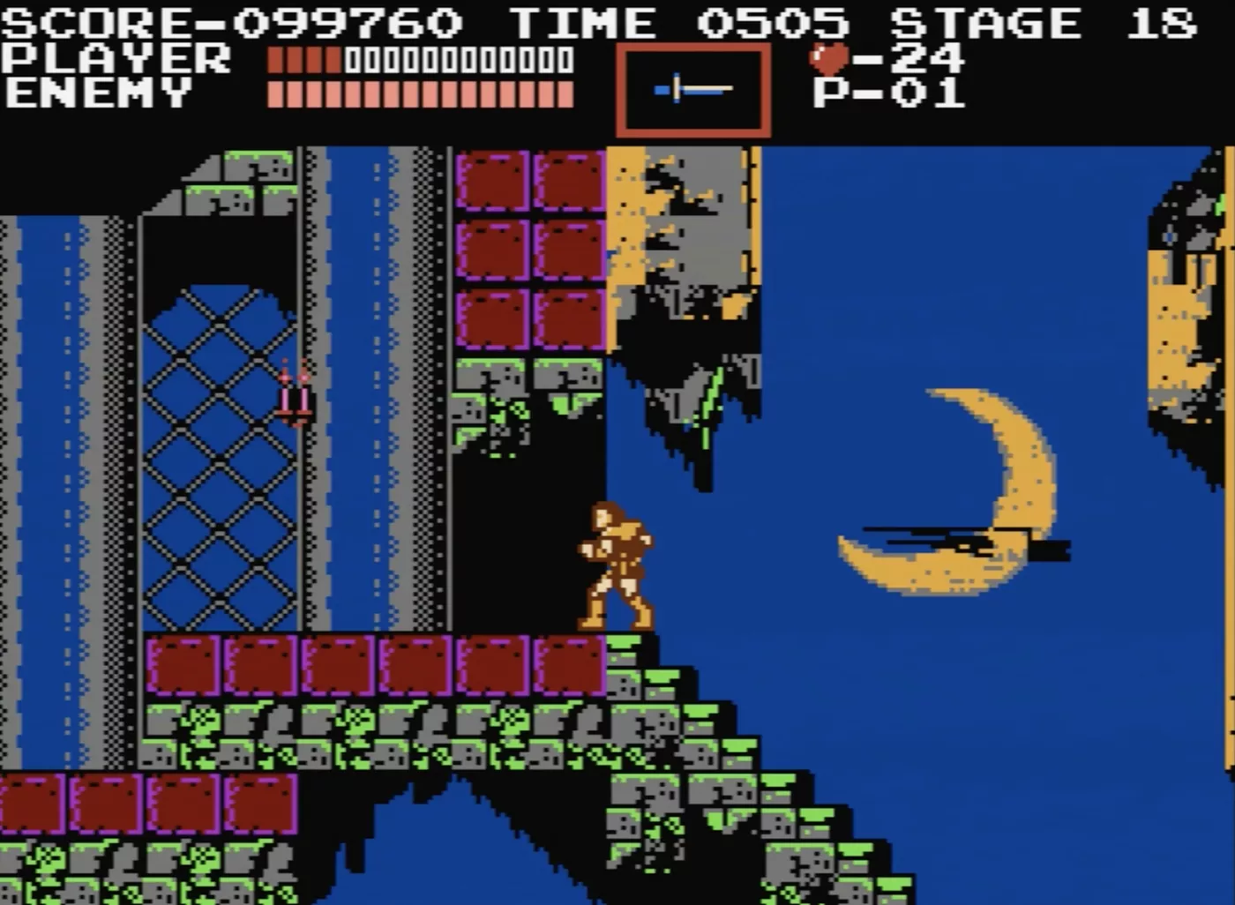

# Backstory

You are a praised archer the best at what you do. You make your way to the castle to be knighted for your efforts but without any warning the sky becomes dark and grim with fire falling from the sky. You are hit knocked unconscious with the world around you going to hell

All you hear is a voice in your head saying only one thing “Follow the Flame”. You awaken with your face burned and demonic energy ingulfing you. You pick up a burned cloth and cover your scars then continue to pick up your bow and sword. The rest is up to you do you follow your heroic ideals which have brought you to where you are now, or do you follow the Flame.

In final version of the game you will be able to follow your own path save the town or follow the flame to choose a darker scenario.

## Feature Goals

Below is a list of features I plan to implement into the Final Version organised by how high of a priority.

### Top Priority

* Megaman x style movement
* Four different enemy types
* Switch from sword and bow instantly
* Player/Enemy health
* Health potions
* Player animations ,Weapons and Enemy animations

### Mid Priority

* Ladder animation
* Chose to read story option
* Pause menu
* Enemy death animation
* Explosive arrows
* Easy level transition

### Low Priority

* Voice over
* Moving turrets
* Music chooser

## Controls

WASD to move

Left click to use sword

Right click to use bow

Shift to role

E to interact

## Software Used

* Unity
* GitHub
* Google Drive
* Maya 2018
* Discord
* Audacity

## Scrapped Ideas

### 2D RPG

This was going to have a similar story to rise again but with much more characters and different enemy types and world types and throughout the game you would gain different abilities and weapons unfortunately time restraints wouldn’t allow for this to be done so it was scrapped

This game would have featured:-

* Hub(s) the player can navigate to find quest(s)
* Random enemy encounters in certain areas
* Slash based combat
* Original story and characters
* Sprite based graphics
* Story progression

Fps Racing game

This game would have involved the player seeing through the eyes of the car but this was scrapped pretty early as I had no inspiration to make it.

# Requirements Specification

## Functional Requirements

* Level-Town
* At least 4 levels (town and castle and other places)
* At least 2 working enemy types
* Consistent damage values
* Each weapon plays differently
* No need to pick up arrows infinite arrows
* At least 2 types of functional weapons (sword/Bow and Arrow)
* Turrets projectile can collide with enemies and cause damage

## Non-Functional Requirements

* Gothic theme
* Map (town) should have bigger palace in background
* Main Menu (Play/Backstory/Quit)
* Backstory menu
* Enemy animations
* Weapon animations
* UI elements
* Level music
* End game option (Quit)
* Weapon sounds
* Enemy sounds
* Player sounds (jumping, damaged, death)
* Backstory menu music
* Menu music
* Pause menu

## Assets Required

|  |  |  |
| --- | --- | --- |
| **Models** | **Textures** | **Sounds** |
| * Player * Player Death * enemy * Enemy death * Sword * bow * arrow * turrets * bosses * flame * Level * Platforms * Potions | * Fire | * Player jump * Sword swing * Switching weapons * Enemy Idle * Enemy death * Player hurt * Player death * Turret sound * Level music * Menu music |

## Player Interface

* Health
* Corrupting Heart

## Arena

* Hexagon shaped
* Suspended in the air
* Falling off edge teleports player back to centre
* Tron aesthetic
* Neon lights

## Player

* Average HP
* Infinite ammo
* Average size
* Decent movement speed can also roll by pressing shift.

## Enemies

* Desire to kill player
* Becomes ash after death

### Undead - Melee

* Melee type enemy
* Fast movement speed
* Small size
* Aggressively follows the player
* Low health - 50 HP
* 25 points if killed
* Weapon - Claws
* Tries to swarm the player

### Turrets - Shooter

* Ranged, projectile type enemy
* Average movement speed
* Average size
* Tries to stay just within attacking range of the player - 8 meters
* Medium health - 100 HP
* 50 points if killed
* Weapon - Medium fire rate projectiles
* Will get within range of the player and circle around them, continuously shooting

### Boss - ???

* Ranged, projectile type enemy
* FAST movement speed
* NORMAL size
* Follows player
* High health - 300 HP
* Main Weapon - bow
* Extra Weapon - sword
* This is a shadow of the player if you can do it so can he.

## Weapons

### Sword

* This weapon only hits the ememy back you are an archer that is were the damage is
* Medium attack speed
* Medium damage

### Bow

* FAST fire rate
* High damage
* Needs to charge before firing - 1.5 seconds

# Business Model/Games Development Life Cycle

I settled on using the Agile life cycle as I had already applied some of its aspects by myself, such as our prioritisation of features, or mandatory vs optional requirements initial documentation.

The agile methodology is similar to the standard waterfall methodology as it follows the same sequence of stages – Planning, Analysis, Design, Implementation, Testing and Maintenance. However, this method aims to catch problems early by releasing multiple iterations of the same the program rapidly with small incremental changes for testing, catching issues early in development before they become a bigger one further down the line. This allows me to make changes if we know something in the game won’t work before it’s too late.

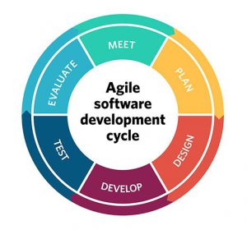  
  
  
I feel the Agile life cycle will help me greatly in working towards my goal as I am working myself in the labs I go down the priority list and move down each time I’m done.

### Usability testing

Usability testing will be covered by me and friends. The aim of this is to give me feedback on how the game runs and operates.

### Functionality testing

Functionality testing will be covered by me where I will look over each script, class and method for errors or mistakes. As part of functionality testing i will produce a test strategy and test log.

The methods of testing are discussed in greater detail below:-

## Testing Methods

Before our game is complete it is a good idea to lay out a test plan which will outline what approaches and methods we will use to test the functionality of our classes and the app’s overall usability. This will be done through the following methods:-

* **Unit testing** – the testing of individual components such as methods, functions and classes through ‘dummy’ code that won’t be used in the final prototype build of the game.
* **Integration testing** – the testing of how all of our classes work together without causing errors or crashes. Integration testing is usually done through ‘top-down’ and ‘bottom-up’ approaches. ‘Top down’ approach means to test elements at the top most level. Typically this means from the user’s/player’s point of view. ‘Bottom up’ approach means to test from the opposite end and start from the system’s functions upwards.
* **System testing** – System testing is done after most of the coding is done to see that your program matches the functional and non-functional requirements stated in the brief. This is as simple as making sure the program produces the correct results when run.

Additionally these methods can be categorized as either ‘White box’ or ‘Black box’ testing. ‘White box’ is a method of testing that tests the internal structure and workings of a program where as ‘Black box’ is a method which just covers the program’s functionality and output. For example, both my Unit testing and System testing will be considered as Black box testing and the Integration testing will be treated as white box testing.

# Sound Design

A lot of the sounds and music I got were from online and it allowed me to chose the right tone for each level and sound for the enemies and player. Were dark levels the music get more chaotic than the light levels were its more heroic sounding a slower based. The enemis I really wanted the player to get the effect that you struck down a person pretty much and the sense of dome and gloom from the player characters death.

# Inspiration

As I mentioned before the main inspiration behind the game was the megaman x series and the castlevania series for the design and theme of the game as megaman x was used for the gameplay. I was also inspired by old Knights tales and story’s that I was told at a young age

### Mechanics

The game mechanics were mostly inspired by games I played in the past that being megaman x. This effects directly into my character being able to move easy and jump and role the same as well. In the final build I plan on implementing a wall jumping mechanic based on this. The bow and arrow mechanics are based on a more medieval version of the blaster as well ie the longer you hold the shoot button the stronger the attack I did the same with the bow and arrow. The sword is purely to move enemies out of your way. In the final build I may add an easy mode with instant sword kill but it kind of ruins the story. The rolling mechanic lets you quickly avoid and enemy or you can use it to cross a platform easier. The enemy’s only attack if they see you that includes the turrets so watch out. To chose between which level you want light or dark this was simply done by having separate portals for each in the first level then it will translon you to which ever choice you made.

### Story/Backstory

The story is very important to me and it certainly is a main focus of the game giving the player the choice and the reason to do what they wish. Although I am still debating if I want to add voices for these scenes or just have it be text the story can be found below.

You are a praised archer the best at what you do. You make your way to the castle to be knighted for your efforts but without any warning the sky becomes dark and grim with fire falling from the sky. You are hit knocked unconscious with the world around you going to hell

All you hear is a voice in your head saying only one thing “Follow the Flame”. You awaken with your face burned and demonic energy ingulfing you. You pick up a burned cloth and cover your scars then continue to pick up your bow and sword. The rest is up to you do you follow your heroic ideals which have brought you to where you are now, or do you follow the Flame.

In final version of the game you will be able to follow your own path save the town or follow the flame to choose a darker scenario.

### Enemy Design

The enemies a wanted them to look as undead as possible and you don’t get more than that with skeletons. I also wanted there death to look good as I want it to effect the player these were people once and you chose to do this as the enemy of the game has suffered the same fate as the player. The turrets I wanted a demonic looking crossbow and I think it could be better I might change it for the final version.

### Aesthetic

I like the medieval look and I like story’s about knights but I also like a good horror story and that’s how you get the world of zero. I wanted the towns to look like your basic rpg quest town but then when everything goes to hell so does the level. I want the player to look at the place afterwards and feel dread.

# Concept Art - Enemies



# 

# Concept Art - Player HUD

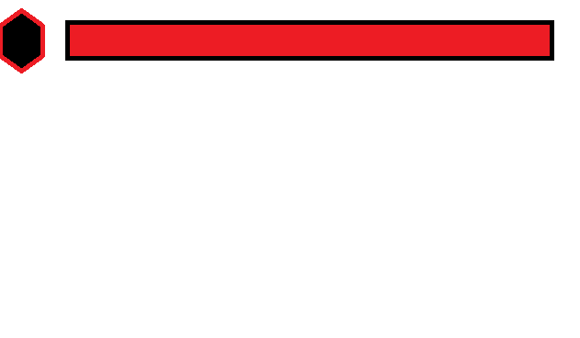

# Final Design

## Enemy



## Turret



## Player

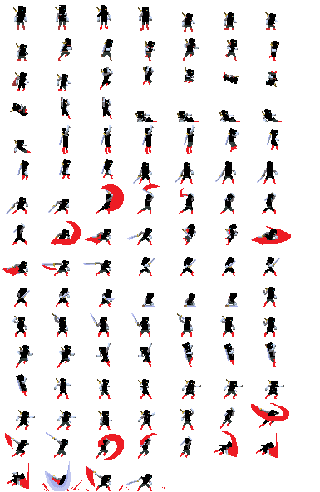

# UML Diagrams

All diagrams will be added in an updated version of the documentation.

### 

# Test Log

|  |  |  |  |  |
| --- | --- | --- | --- | --- |
| **Test** | **Input** | **Expected Results** | **Actual Results** | **Comment** |
| Player movement | ‘W’ | Player moves forward | As expected |  |
|  | ‘S’ | Player moves backwards | As expected |  |
|  | ‘A’ | Player moves left | As expected |  |
|  | ‘D’ | Player moves right | As expected |  |
| Pause game | ‘Esc’ | Game freezes, Player HUD is disabled, Pause menu and controls panel enabled | As expected |  |
| Jump | ‘Space’ | Player jumps | As expected |  |
| Roll | Shift | Player roles as expected | As expected |  |
| Sword attack | Left click | Player slashes with their sword | As expected |  |
| Quick bow attack | Right click | Player quickly launches arrow | As expected |  |
| Long hold bow | Right click hold | Player holds the arrow for as long as they like | As expected |  |
|  |  |  |  |  |
|  |  |  |  |  |
|  |  |  |  |  |
| Player hurt by enemies | Enemy attacks player | Player loses some health | As expected |  |
| Enemies hurt and killed by player | Attacking enemy | Enemy loses health until it reaches 0, death animation plays, enemy model disappears | As expected |  |
| Game Over | Player health reaches 0 | Game pauses, Game Over panel | As expected |  |

# 

# Difficulties

Some features have still to implemented for the final build but I feel confident were I am

* Sound
* I cant seem to get the enemys to make there death sounds and the same for the player.
* Other sounds seem to work like the music so I don’t understand but I plan to fix it.
* Programming

Getting the enemy to stop falling of the side of the map I eventually fixed this by using colliders.

* Animation
* I don’t Think the main player looks bad but I feel some improvements are needed.

# Sources/Credit

* Brackeys YouTube channel
  + Video tutorials for basic game mechanics/concepts
* Freesound.org
  + Various sound effects
  + And music
  + Main menu theme
  + Gameplay theme
* Anonymous playtesters
* Unity asset store for providing some very useful assets.
  + Giving feedback on gameplay mechanics, difficulty scaling, overall look and feel of the game

### Technical Design

This game will be developed using the unity engine and will be programmed in c# with assets both developed and borrowed from the unity asset store page . The game will run on both windows pc and Linux system and should work on the most up to date versions.Most of the hard ware I use from home or bring in my laptop the current processor is and i7 and a nivida 1070 graphics card and 16gb of ram. Most files will be unitys meta files and sound will be wav files. Images will be both png and jpeg. I also use a tile map software which is realy easy to use with unity’s default software. Other software I will use are maya and github and software called piskel for models.

## Mechanics and Gameplay

The main rule of the game is kill the enemies if you like and get to the next level to proceed the story and fight bosses and see which ending you get. There is a simple move mechanic in the game were you can run jump and roll to doge and get pass platforms. The combat mechanics are very simple the sword allows you to push back enemies but not kill for any pacifists out there and the bow and arrow allow you to kill multiple enemies at the same time.

The mechanic for the enemies works as followed the enemy goes on its patrolled path if it sees you it will attack you and decrease you health the turret is different if it sees you it will fire an arrow at you every 4 seconds. The bosses are shadows of the player or the light of the player matters what path you chose in game. They have a bow and arrow and can do everything you can do and will attack you on sight. The game moves on when you do if you go to the dark side 3 levels in you could be offered the chance to go back to the light and vice versa. Its story based game so the flow continues the more you learn about your fate. The game was mostly worked on from home without many issues other than my computer dying and me losing 2 weeks of work but I got it back so that was all good. I also managed to get a lot done in the labs as I used my laptop as the labs computers were kind of slow and would not work a lot. The user interface isn’t as simple as I first made out the final version is the players health bar and a picture of there heart now depending on which path you chose these will either turn black or go back to red that’s up to the player to decide. I wanted the ui to be simple and not have much cluttering up the screen.

## Showing my work online

I mostly uploaded clips to my YouTube channel as its really easy to do

You can view that at this link

<https://www.youtube.com/channel/UC8TOz1Oj1LxmBeAT_OQeY-g?view_as=subscriber>

